ooxWord://word/media/image1.jpegooxWord://word/media/image3.jpeg**Developing Websites for Accessibility Getting Started: 201**

**Skills required:**

• HTML

• CSS

• Javascript

**Instructions:**

• Develop the User Interface using **HTML, CSS, Javascript** (and if needed,

JQuery). Use proper semantic markup to write HTML.

• Code validation should be done for the following:

o HTML [(https://validator.w3.org/](https://validator.w3.org/) )

o CSS [(http://csslint.net/](http://csslint.net/) )

o Javascript [(http://jshint.com/](http://jshint.com/) )

• The entire web page should be compatible with **WCAG 2.1 Level-AA (this**

**makes it ADA compliant website).**

Web accessbility guidelines - <https://www.w3.org/TR/WCAG21/>

• Minify the CSS and JS code.

• Web pages should be adaptable and compatible with IE9, and latest version of:

Chrome, Firefox, MS Edge. Deliverables must also be responsive with all the

mobile devices.

ooxWord://word/media/image5.jpegooxWord://word/media/image7.jpeg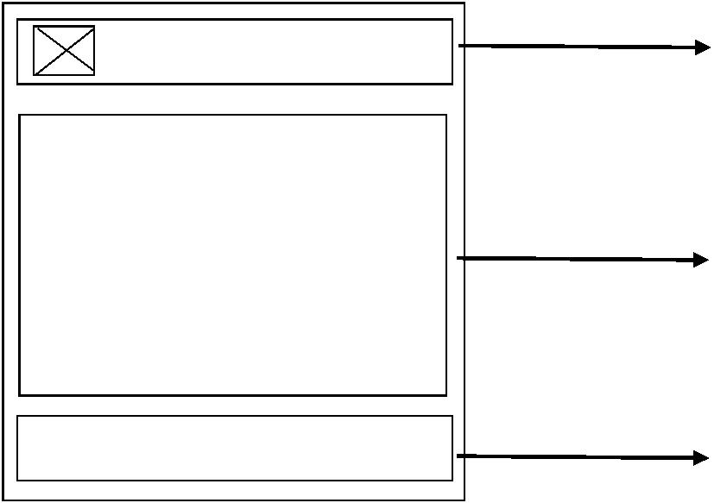**What to implement**

**Requirement 1**:

Create the web pages which includes the following:

• Landing page (Home page)

o The landing page contains the header which contains logo, search bar

and the navigation, page content and the footer.

o The page content should contain 1 video, an image and sample content.

• About Us page

o About us inherits the header and footer.

o Page content has some sample content with an audio.

• Contact

o Contact page inherits the header and footer.

o Page content should have the contact information and a simple form.

Home About-Us Contact Header – logo, searchbar, navigation

links

Page content – Sample page content

Footer – Footer links, copyright

information

**Requirement 2:**

Compliance with WCAG 2.1 Level-AA

**Checklist:**

|  |  |  |
| --- | --- | --- |
| 1 | **Standards, Conventions and Best Practices** | |
|  | 1.1 | Ensure the guidelines are followed:  <https://www.w3.org/TR/WCAG21/> |
|  | 1.2 | Ensure proper folder and module structures, use a meaningful content to convey meaningful information for the screen readers. |
|  | 1.3 | Ensure proper usage of coding standards and guidelines.  <https://www.w3schools.com/htmL/html5_syntax.asp> |
|  | 1.4 | Color contrast analyzer tool should be used to check the contrast ratio.  <https://www.w3docs.com/tools/color-analyzer> |
| 2 | **UI, Testing** | |
|  | 2.1 | Application should be tested using any screen reader  [Chrome Vox Chrome extension](https://chrome.google.com/webstore/detail/screen-reader/)  [NVDA](https://www.microsoft.com/en-in/p/nvda-nonvisual-desktop-access/9nvl6z0tm57d?activetab=pivot:overviewtab) |
|  | 2.2 | Ensure that the application is used by all the users including the people with disabilities. |
|  | 2.3 | Ensure the application has properly followed the [WCAG guidelines](https://www.w3.org/TR/WCAG21/). |
|  | 2.4 | Application should be compatible in major browsers and responsive in mobile devices. |
|  | 2.5 | Use of Unit testing frameworks is a plus. |

**Copyright Information**

This document is the exclusive property of Mindtree Limited (Mindtree); the recipient agrees that they may not copy, transmit, use or disclose the confidential and proprietary information in this document by any means without the expressed and written consent of Mindtree. By accepting a copy, the recipient agrees to adhere to these conditions to the confidentiality of Mindtree's practices and procedures; and to use these documents solely for responding to Mindtree's operations methodology.

**Revision History**

Please keep the latest version on top

|  |  |  |  |  |  |  |
| --- | --- | --- | --- | --- | --- | --- |
| Ver | Change Description | Sections | Date | Author | Reviewer | Approver |
| 1.0 | Initial Draft |  | 03-Jan-2022 | Komala Reddy |  |  |

Mindtree Limited

Contact Information

Komala Reddy

Email: komala.reddy@mindtree.com

Global Village, RVCE Post, Mysore Road,

Bangalore-560 059

INDIA

Phone- 91 (80) 6706 4000

Fax- 91 (80) 6706 4100

Web- [www.mindtree.com](http://www.mindtree.com)